**Gas Leakage Monitoring and Alerting System**

|  |  |  |  |
| --- | --- | --- | --- |
| **Team ID** | PNT2022TMID14468 | | |
| **Team Leader &Member** |  | Thirumoorthi G |  |
| Rohit N |
| Santhosh S M |
| Sugaibu Rahuman K |
| **Project Name** | GAS LEAKAGE MONITORING AND ALERTING SYSTEM FOR INDUSTRIES | | |

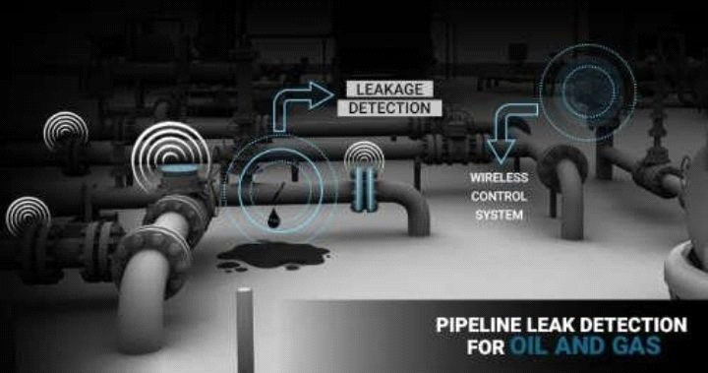**TECHNOLOGY ARCHITECTURE:**

GAS LEAKAGE SYSTEM IN INDUSTRIES:

